Living Wage Day
WHEREAS, chronic poverty is one of the biggest challenges to sustainable, diverse, and healthy communities; and
WHEREAS, the minimum wage has not increased in North Carolina for an entire decade beyond the federally mandated minimum of $7.25, which has lost 16% of its value over the past ten years due to cost of living increases; and
WHEREAS, the costs of housing, food, child care, and health care have increased substantially in the ten years since the federal minimum was last raised; and
WHEREAS, the current living wage in Orange County is $14.25 per hour, nearly double the state and federal minimum; and
WHEREAS, far too many workers in Orange County make less than a living wage; and
WHEREAS, a living wage can lift workers out of poverty and towards the middle class; and
WHEREAS, employers who pay their workers a living wage report substantially less turnover, better job performance, and higher levels of positive customer engagement; and
WHEREAS, Orange County Living Wage has certified over 200 employers who voluntarily pay a living wage and promotes them locally to build a base of engaged, informed consumers who support living-wage-certified businesses and nonprofits; and
WHEREAS, Labor Day is a national holiday in recognition of the contributions of workers to our economy; therefore, it is an appropriate time to raise our voices in support of adequate compensation for all.
NOW, THEREFORE, BE IT RESOLVED, that I, Lydia E. Lavelle, Mayor of Carrboro, North Carolina, a living-wage-certified employer, do hereby proclaim Labor Day 2019 as Living Wage Day. I encourage consumers to support businesses that pay their workers a living wage, and I urge residents, employers and civic leaders to support the goal of providing all workers with a level of compensation that allows them to share in the prosperity that this nation can provide.
This, the 2nd day of September 2019.
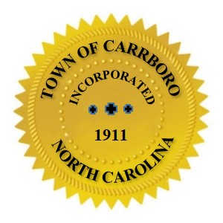

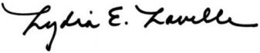

Lydia E. Lavelle, Mayor

