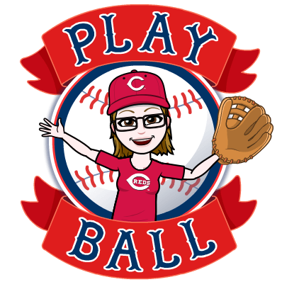
YOU ARE INVITED TO PLAY
CARRBORO MAYOR LAVELLE’S
BASEBALL/SOFTBALL VIRTUAL SCAVENGER HUNT!

MON, APRIL 20 | TUES, APRIL 21 | WEDS, APRIL 22 | THURS, APRIL 23 | FRI, APRIL 24 | SAT, APRIL 25 | SUN, APRIL 26
A PICTURE OF A BASEBALL OR SOFTBALL | A PICTURE OF A BASEBALL OR SOFTBALL BAT | A PICTURE OF A BASEBALL GLOVE | A PICTURE OF A BASEBALL FIELD OR STADIUM | A PICTURE OF PARTICIPANT WEARING A BASEBALL OR SOFTBALL JERESEY, SHIRT, OR CAP | A PICTURE OF A BASEBALL CARD | A PICTURE OF PARTICIPANT DOING A “MOVEMENT” FOUND IN A BASEBALL GAME
BONUS: E-mail us the name of one of the major league or minor league mascots | BONUS: E-mail us one of the rules of baseball or softball | BONUS: E-mail us the name of Mayor Lavelle’s favorite professional team | BONUS: E-mail us a short recording of participant reading a stanza of a baseball poem | BONUS: E-mail us the name of a baseball player born on this day | BONUS: E-mail us a short recording of participant singing a few words of “Take Me Out to the Ball Game” | BONUS: Watch a baseball movie and tell us about it (either by e-mail or recording)

This is an initiative of PLAY BALL, a partnership between the U.S. Conference of Mayors and Major League Baseball.
Rules:
1. The Hunt runs from Monday, April 20 to Sunday, April 27, 2020.

2. Participants must be under the age of 18, must live in Carrboro, and have permission from their parent/guardian to participate.
3. Participants are allowed to enter once per day with a picture, and once per day for the bonus question.
4. Participants can send pictures of items found in their house, or items/places found on the internet.
5. Entries must be e-mailed to baseballhunt@townofcarrboro.org.
6. Entries must include the name and age of the sender, although the e-mail can come from another person’s e-mail account.
7. At the end of the Hunt, the winner will be drawn by Mayor Lavelle from all of the entries, and will receive a prize.

